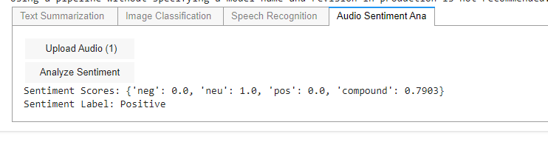

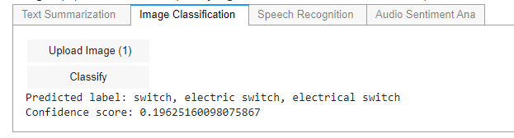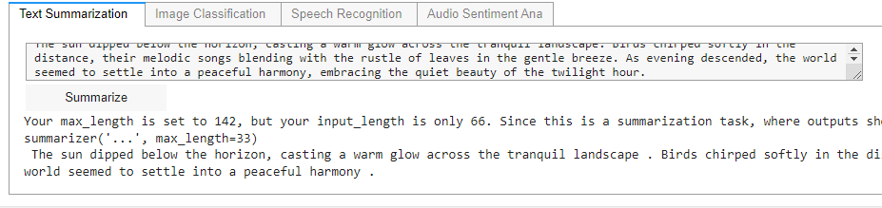

Code:

import ipywidgets as widgets

from IPython.display import display, Audio, clear_output, Image as IPyImage

import base64

from io import BytesIO

from transformers import pipeline

import speech_recognition as sr

from PIL import Image

from vaderSentiment.vaderSentiment import SentimentIntensityAnalyzer

import time

# Initialize models

text_summarizer = pipeline("summarization")

image_classifier = pipeline("image-classification")

speech_recognizer = sr.Recognizer()

sentiment_analyzer = SentimentIntensityAnalyzer()

# Text Summarization Tab

text_input = widgets.Textarea(placeholder='Enter text to summarize', layout={'width': '50%'})

summarize_button = widgets.Button(description="Summarize")

text_output = widgets.Output()

def summarize_text(b):

with text_output:

clear_output()

try:

summary = text_summarizer(text_input.value)[0]['summary_text']

print(summary)

time.sleep(10) # Display output for 10 seconds

except Exception as e:

print(f"Error: {e}")

summarize_button.on_click(summarize_text)

text_tab = widgets.VBox([text_input, summarize_button, text_output])

# Image Classification Tab

upload_image_button = widgets.FileUpload(description="Upload Image")

classify_image_button = widgets.Button(description="Classify")

image_output = widgets.Output()

def classify_image(b):

with image_output:

clear_output()

try:

image_data = next(iter(upload_image_button.value.values()))['content']

# Convert image data to base64

image_base64 = base64.b64encode(image_data).decode("utf-8")

result = image_classifier(image_base64)

print("Predicted label:", result[0]['label'])

print("Confidence score:", result[0]['score'])

except Exception as e:

print(f"Error: {e}")

classify_image_button.on_click(classify_image)

image_tab = widgets.VBox([upload_image_button, classify_image_button, image_output])

# Speech Recognition Tab

record_button = widgets.Button(description="Record")

audio_output = widgets.Output()

def record_audio(b):

with audio_output:

clear_output()

try:

with sr.Microphone() as source:

print("Say something...")

audio_text = speech_recognizer.listen(source)

print("Recognizing...")

text = speech_recognizer.recognize_google(audio_text)

print(f"Text: {text}")

display(Audio(data=audio_text, autoplay=True))

except Exception as e:

print(f"Error: {e}")

record_button.on_click(record_audio)

audio_tab = widgets.VBox([record_button, audio_output])

# Audio Sentiment Analysis Tab

upload_audio_button = widgets.FileUpload(description="Upload Audio")

analyze_audio_button = widgets.Button(description="Analyze Sentiment")

audio_sentiment_output = widgets.Output()

def analyze_audio_sentiment(b):

with audio_sentiment_output:

clear_output()

try:

audio_data = next(iter(upload_audio_button.value.values()))['content']

# Perform sentiment analysis

sentiment_scores = sentiment_analyzer.polarity_scores(str(audio_data))

print("Sentiment Scores:", sentiment_scores)

# Determine sentiment label

if sentiment_scores['compound'] >= 0.05:

sentiment_label = "Positive"

elif sentiment_scores['compound'] <= -0.05:

sentiment_label = "Negative"

else:

sentiment_label = "Neutral"

print("Sentiment Label:", sentiment_label)

except Exception as e:

print(f"Error: {e}")

analyze_audio_button.on_click(analyze_audio_sentiment)

audio_sentiment_tab = widgets.VBox([upload_audio_button, analyze_audio_button, audio_sentiment_output])

# Display tabs

tabs = widgets.Tab(children=[text_tab, image_tab, audio_tab, audio_sentiment_tab])

tabs.set_title(0, 'Text Summarization')

tabs.set_title(1, 'Image Classification')

tabs.set_title(2, 'Speech Recognition')

tabs.set_title(3, 'Audio Sentiment Analysis')

display(tabs)